GPU environment for model trining
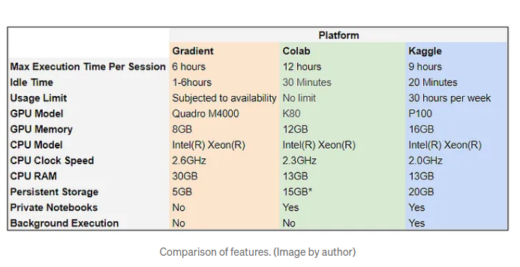
url: https://towardsdatascience.com/free-gpus-for-training-your-deep-learning-models-c1ce47863350

